**Com Controller MCAL**

GPIO Port /DIO

Case 1: Configured as output from MCU

Port 20 pin 0

On generating using tresos tool for Port an interface will be created in Dio_Cfg.h

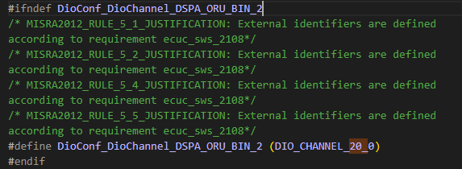

And it can be used to write the channel in necessary iohw module



Case 2 Configured as input to mcu

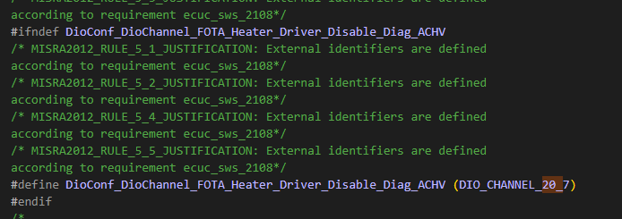

In IOHW_corresponding swc module it is used to read the port value

